THIS ROLE IS FULLY FUNDED BY THE NATIONAL LOTTERY COMMUNITY FUND 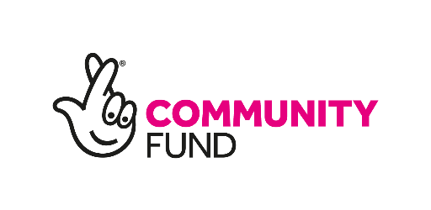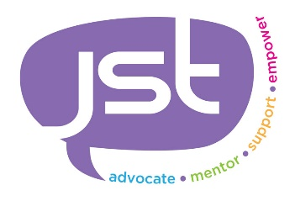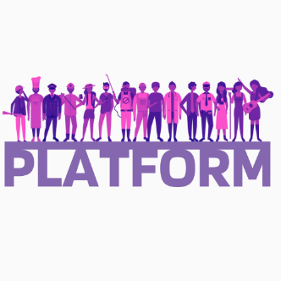

JOB DESCRIPTION

Organisational Role:
ROLE TITLE: Platform Connector REPORTS TO: Team Senior
CONTRACT: Fixed Term until March 26 HOURS: 37 per week

ROLE PURPOSE: To develop, organise and coordinate group activities and short courses in the community for the needs of all Platform participants. By working as part of a team, you will identify possible participants to access the Platform project, look at the individual's needs, and encourage them to connect with the community within a group setting. You will be working towards supporting the individuals in achieving their aims and ambitions in life and overcoming many barriers and complex needs. Working as a key member of the Platform team to deliver the project and embed JST's values and visions.
LOCATION:
The post holder(s) will be based in community locations around Dudley & Sandwell. With the main office base of:

JST/YMCA
Room 5c – 38 Carters Green,
West Bromwich
B70 9LG

EQUALITY & DIVERSITY
Just Straight Talk promotes integrity and good conduct in all employment matters. We will ensure that all applicants are treated fairly, consistently and impartially for all posts. JST will seek to avoid discrimination on the grounds of gender, age, race, disability, marital or civil partnership status, gender reassignment, race, sexual orientation, religion or belief and pregnancy or maternity throughout every stage of the recruitment process.

The post-holder must complete an Enhanced Disclosure and Barring Service Check as the Project specifically targets legally defined vulnerable adults.

Key/Generic Accountabilities | Key Generic Activities/Decision Areas
People Management | - Promoting & encouraging a culture of continuous performance improvement at both an individual and Platform project level  - Identify and obtain referrals for the Platform project.  - Identify suitable individuals for the Platform project and establish their needs and requirements  - Setting up and running group activities to enable and encourage participation and connections to the community  - Assigning new participants and work within a team for the seamless delivery of the Platform project  - A good knowledge of working to address the needs of unemployed and economically inactive participants.  - Have a good standard of knowledge of external organisations in and around the local area and be aware of referral processes.  - Leading, organising, and coordinating community activities/events and the promotion of these  - Completing all relevant paperwork and maintaining written and electronic documents to be stored in a database. Paper-based copies are then stored away to comply with the Data Protection Act  - Facilitating partnership working across both Dudley & Sandwell  - Supporting and contributing towards the delivery of the Platform project, communications, and marketing, such as social media, leaflets, posters, and promotional campaigns.  - Arranging and co-coordinating events, activities, training, and employment opportunities for Platform participants.  - Identifying new and existing opportunities within the local community and encouraging participants to engage with these.  - To protect the interests and dignity of all Platform participants who are vulnerable and keep up to date on changes with safeguarding procedures.  - Ensuring Participants are fully involved in the support provided by Platform staff  - Monitor all health and safety at work arrangements and demonstrate an ability to adhere to good working practices as laid down by JST policy and procedures.  - Demonstrate a flexible approach to the job role.  - Dealing with internal and external agency enquiries.  - To independently supervise and facilitate activity sessions  - To support and participate in the occasional group outings  - To attend meetings and training relevant to the role  - To carry out any other duties as requested by the team senior.
Quality | To ensure JST & Platform quality standards are maintained:  - Ensure and maintain a high standard when delivering support.  - Ensuring records are up to date with participant support sessions and all contact is recorded.  - Participating and utilising systems daily  - Completing Platform paperwork to a high standard.  - Ensuring the project is committed to and seeks out opportunities to actively promote equality and diversity and support activities for people from marginalised groups.  - Ensuring you act promptly and adopt a quick turnaround of amendments to participant paperwork and files where required so that we do not jeopardise audits and results.  - Maintain adequate records of other support services, employers, training providers and establishments for participants to utilise and adhere to the deadline for employer engagement.
Own Development | To continuously review one's own performance and development needs:  - Participation in internal and external training opportunities.  - Taking responsibility for one's own self-development
Health, Safety and Risk management | To ensure health and safety standards are maintained, and risk is mitigated to the lowest level possible:  - Ensuring a good standard of housekeeping within internal and external locations used  - Being responsible for ensuring H&S and safeguarding concerns are appropriately reported and action taken in a timely manner.  - Ensuring that task-based and participant risk assessments and reviews are undertaken and identified risks are managed and mitigated where possible  - Ensure risk assessments have been completed for all community venues.  - Follow the formal reporting process of incidents and accidents
Compliance | To ensure compliance with internal and external standards and codes of conduct by:  - Meeting all regulatory requirements  - Adherence and compliance checks of team of The Data Protection Act 2018 and GDPR  - Adherence and ensuring compliance with all aspects of Safeguarding and the procedures related to it  - Compliance with Just Straight Talks code of conduct and policies and procedures.  - Participation and preparation for regular pre-audits and audits ensure results are promptly acted upon.
Participant caseload | To monitor caseload, ensuring high-quality standards.  - Managing own caseload and identifying possible results & impact  - Delivering allocation of new referrals for the Platform project in a timely manner, ensuring the process is monitored, and feedback is given to the referral agency  - Conducting joint or single risk assessments for either new participants where risk is identified or for new activity and providing contingency plans  - Completing the paperwork, reviews and action plans of new participants  - Providing support with participant goal planning and review stages to ensure quality record keeping from the start and each stage of the participant journey on the Platform project  - Completing quality case studies to meet lottery deadlines  - Completing employer surveys to meet Platform deadlines.  - Ensuring and encouraging participant involvement, groups and person-centred approaches are embedded within the day-to-day running of the Platform Project.
Deputising for Seniors | To represent JST & deputise for the Senior where required by:  - Participating in Platform team meetings and sharing feedback and good practice to other members of the staff  - Carrying out specific tasks on behalf of the Team Senior.
Partnerships | To work with a multi-disciplinary approach with a range of Platform partners & other statutory and non-statutory bodies:  - Participate/contribute with advocating on participants' behalf and refer people to other agencies and services when appropriate.  - Build professional working relationships with partner agencies to develop and provide key benefits to both the project and the participants  - Ensure feedback is always given to partner agencies  - Develop new lasting partnerships to identify & develop opportunities and effectively communicate to the team to ensure the full team utilises these accordingly
Misc | Undertaking any other duties required by Team Senior.

Person Specification (Essential Only)

Professional skills/expertise and Qualifications:
- Proven track record in the relevant area
- In-depth knowledge of support services around employment, training and education
- Experience working with disadvantaged people
- Experience in working towards individual and team objectives
- A high standard of numeracy, literacy and IT skills
- Effective oral and written communication skills and ability to adapt communication to suit the audience
- Good time management skills and ability to work to deadlines
- Approachable, responsive and an excellent communicator
- Ability to build trust and rapport with people
- Responsive to people’s needs
- Be able to develop effective working relationships with external agencies
- Be proactive and with a ‘can do’ personality
- Good knowledge of Dudley & Sandwell borough

Additional specific requirements (Desirable)

Professional skills/expertise and Qualifications:
- Holds relevant and appropriate qualifications (educated to NVQ level 3 or willingness to train)
- In-depth knowledge and understanding of participant needs in terms of long-term unemployment and economically inactive
- A demonstrable belief in a value-led approach to working with participants with single or multiple needs
- Sound knowledge and understanding of the DWP benefits system and the impacts this has on participants accessing training and employment
- Experience in working with participants with a range of barriers and complex needs
- Knowledge around issues that impact an individual’s employability, i.e. homelessness, debt, mental health, disabilities, domestic abuse etc
- A good understanding of the fundamental issues facing marginalised groups
- Experience in interfacing with other support agencies
- Experience in setting up and arranging group activities
- Car driver with access to own vehicle

